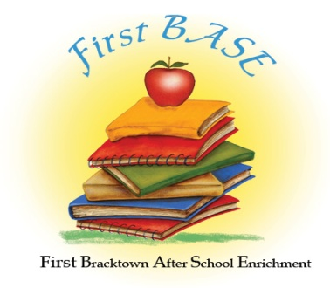

APPLICATION

Child’s Full Name _________________________________________

Date of Birth _________________ Social Security Number ______-______-_______

Gender M____ F____

Parent’s Name_____________________________________________

Parent’s Email address__________________________________________

Address __________________________________________________

Telephone Number _________________________________________

Do you have any concerns about your child’s overall health and development?
Yes_______ No______ Don’t Know______

If yes, please describe your concerns:_______________________________

Does your child have any allergies? Yes ______ No_______

If yes, please list________________________________________________
______________________________________________________________

Is your child on any medications? Yes______ No______
If yes, please list________________________________________________
______________________________________________________________

Was your child previously enrolled in a head-start or daycare program?
Yes______ No_______

If yes, Program Name______________________

Are you a member of First Baptist Church Bracktown? Yes _____ No_____

Official Use Only
Date received _________________
Deposit _________________
Class _________________

